

第十六届中国北京国际科技产业博览会

时 间：2013年5月22-26日
地 点：中国国际展览中心（老馆）

此手册系关于本届展览会及展览主办单位所提供服务的综合情况。仔细参阅本手册，可使全部有关事宜得以顺利进行。
参展商应在截止日期前将有关表格填写完毕并返还给展览主办单位。展台装修、展品运输及旅游服务等未包括在此手册中，有关资料将分别由装修代理公司、运输代理公司及旅游代理公司向各参展商寄发。另外，贵公司应尽快与上述公司联系，以确保服务。

综 合 信 息

1. 名称：
第十六届中国北京国际科技产业博览会
简称“第十六届科博会”
2. 地点：
北京 中国国际展览中心（老馆） （邮编:100028）
地址：北京朝阳区北三环东路6号
电话：（010）84600000
3. 主办单位:
中华人民共和国科学技术部
中华人民共和国商务部
中华人民共和国教育部
中华人民共和国工业和信息化部
国务院国有资产监督管理委员会
中国国际贸易促进委员会
中华人民共和国国家知识产权局
北京市人民政府

4. 顾问单位:
中国科学院
中国工程院
中国企业联合会
中国科学技术协会
5. 支持单位:
中央电视台
6. 承办单位:
北京市贸促会
7. 展览工作日程:
⑴ 展商报到:
地点：北京 中国国际展览中心（老馆）1号馆 "参展商报到处"
时间：2013年5月19日-21日 （8:30〜16:30）
⑵ 布展日期: 2013年5月19日-21日 (8:30-17:30)
＊ 5月19日上午开始布展, 20日下午展品开始进馆。
⑶ 展览日期: 2013年5月22-25日 (9:00-17:00)
2013年5月26日 (9:00-15:00)
＊ 参展商每日上午8:30可以进入展馆。
⑷ 撤展日期: 2013年5月26日 (15:00-21:00)
＊展览闭幕后，电源将于2013年5月26日下午3时切断。所有租用的家具等物品将被搬走。请参展商将放于储柜中的财物等取走。展台拆撤工作将在5月26日下午3时开始进行。展馆要求在5月26日晚上9时前清理干净。遗留在展馆的物品将被视为遗弃物。
8. 参展费用:
⑴ 所有参展费用最迟不得超过2013年4月30日交到北京世界贸易中心。否则，参展商必须于展出前在展场交付现金。
⑵ 参展费用可用人民币支付，以银行电汇形式汇到：
收款人: 北京世界贸易中心
开户行: 中国银行北京西长安街支行
帐 号: 3272 5603 2365
⑶ 请按开据给贵公司的形式发票之要求支付有关参展费用。

This Manual is regarding to the general information of the exhibition and services offered by organizers. Your careful study of the contents of this manual will enable all relevant matters to be processed smoothly. Exhibitors must fill in ALL FORMS and return them to the organizers BEFORE THE DEADLINE.
Manuals regarding booth construction, freight shipping and forwarding, and travel service are separated and will be sent to all exhibitors by official booth contractor, official freight forwarder and travel agent respectively. and also you should contact them mentioned above ASAP for the service.

GEN RAKL INFORMATION
1.THE EXHIBITION:
THE 16TH CHINA BEIJING INTERNATIONAL HIGH-TECH EXPO(CHITEC 2013)
2. VENUE:
China International Exhibition Center (former site), Beijing
No.6 Beisanhuan East Road, Chaoyang Dist., Beijing 100028, P. R. China
Tel: (86-10)84600000
3. HOSTS:
Ministry of Science and Technology, P. R. China
Ministry of Commerce, P. R. China
Ministry of Education, P. R. China
Ministry of Industry and Information Technology, P. R. China
State-owed Assits Supervision and Administration Commission of the State Council, P. R. China
China Council for the Promotion of International Trade (CCPIT)
State Intellectual Property Office, P. R. China
The People's Government of Beijing Municipality

4. CONSULTATION INSTITUTIONS:
China Academy of Sciences
China Academy of Engineering
China Enterprise Confederation
China Association for Science and Technology
5. SUPPORTING ORGANIZATION:
China Central Television (CCTV)
6. ORGANIZER:
China Council for the Promotion of International Trade Beijing Sub-Council (CCPIT BEIJING)
7. EXHIBITION OPERATION:
(1)Registration: May 19-21, 2013 (8:30-16:30)
* Please register at the Organizer Office (Registration Office) at the exhibition site, Hall 1 during the opening hours from May 19-21, 2013.
(2)Build-Up Period: May 19-21, 2013 (8:30-17:30)
* Booth set up starts in the morning of May 19, 2013.
* Freight moves in the hall in the afternoon of May 20, 2013
(3)Exhibition Period: May 22-25, 2013 (9:00-17:00)
May 26, 2013 (9:00-15:00)
* Exhibitors can enter into exhibition hall at 8:30 daily.
(4)Tear-Down Period: May 26, 2013 (15:00-21:00)
* After exhibition closed, electrical supplies will be cut off at 15:00 of May 26, 2013 All rented furniture items will be removed. Please remove all your properties from the cabinets/counters soon after exhibition closing. Dismantling of the stands will commence from 15:00 of May 26. Please note that Organizer Office requires everything to be cleared from the hall by 21:00 of May 26. The items left behind will be considered as abandoned.
8. PAYMENT:
(1)ALL PAYMENT should be received by Show Management no later than April 30, 2013. Otherwise cash must be paid at the exhibition site before you are allowed to exhibit.
(2)Payment should be in US Dollar and payable via bank transfer by T/T to:
ACCOUNT: Beijing World Trade Centre
BANK: BANK OF CHINA, XICHANGAN JIE SUB- BRANCH BEIJING
A/C NO.: 3272 5603 2365
(3)Please make your payment according to the Proforma Invoice which is issued to your company.

USEFUL CONTACT LIST 展览会有关联系公司
SHOW MANAGEMENT: 展览会承办单位:
  Exhibition Dept. of The organizing Committee Office of ICCIE  ATTN: Ms. Liu Jie; Ms. Qi Wei, Mr. Wang Luocheng, Mr. Li Chao  ADD: 2nd Floor Jianbang Business Center, No.19 Nanlishilu, Xicheng District, Beijing 100045, China  TEL:+86-10-68066685, 68066686, 68066669-8010/8021  FAX：+86-10-68066969  E-mail: lj@wtcbj.com, qw@wtcbj.com,  wlc@wtcbj.com, lc@wtcbj.com  http://www.chitec.cn | 文博会组委会办公室展览展示组  联 系 人：刘洁 女士，齐溦 女士，王珞丞 先生，  李超 先生  地 址：北京市西城区南礼士路19号建邦商务会馆2层  邮 编：100045  电 话：+86-10-68066685, 68066686,  68066669-8010/8021  传 真：+86-10-68066969  电子信箱：lj@wtcbj.com, qw@wtcbj.com,  wlc@wtcbj.com, lc@wtcbj.com  网 址：http://www.chitec.cn
OFFICIAL BOOTH CONTRACTOR: 展览会指定装修代理:
Beijing Perfect Creative International Builders Resources Co., Ltd.  ATTN: Mr.Li Hui, Mr. Li Chengyang  ADD: No. 4 Building, Jing’an Xijie, Chaoyang District Beijing 100028 P. R. China  TEL+86-10-84551155； 13911283711, 13810682026  FAX: +86-10-64625934, 64661298  E-mail: lihuipbr@126.com, lichengyang001@163.com | 北京唯美创意国际展览服务有限公司  联 系 人：李辉 先生 历程阳 先生  地 址：北京市朝阳区静安西街4号楼  邮政编码：100028  电话：+86-10-84551155； 13911283711, 13810682026  传 真：+86-10-64625934, 64661298  电子信箱：lihuipbr@126.com,  lichengyang001@163.com
RECOMMENDED CONTRACTOR : 展览会推荐装修代理:
BEI JING HAO TIAN EXHIBITION SERVICE CO.,LTD.  ATTN: Mr.Ke Zunye  ADD: Room 205, No. 1 Building,Wan liu Yi Shui Yuan, East WanLiu Road, Haidian District, Beijing, China  TEL: +86-10-82562545, 13601192829, 13161194757  E-mail: bjhtvip@163.com | 深圳市浩天展览服务有限公司 北京分公司  联 系 人：柯尊烨 先生  地 址：北京市海淀区万柳东路万柳怡水园1号楼205室  电 话：+86-10-82562545, 13601192829, 13161194757  电子信箱：bjhtvip@163.com
OFFICIAL FREIGHT FORWARDER: 展览会指定运输代理:
China International Exhibition Transportation Co., Ltd (CIETC)  ATTN: Mr. Dong Hui, Ms. Zhang Yinan  ADD: 5/F., Hall No.1,(CIEC), 6 East Beisanhuan Road,  Chaoyang District, Beijing 100028, China  TEL: +86-10-84600560, 84600620, 13651049167, 13811241700  FAX: +86-10-84600559  E-mail: dong.hui@cietc.net, nina.zhang@ cietc.net | 中国国际展览运输有限公司  联 系 人：董挥 先生，张伊楠 女士  地 址：北京市朝阳区北三环东路6号中国国际展览中心1号馆5层539室  邮政编码：100028  电 话：+86-10-84600560, 84600620, 13651049167，13811241700  传 真：+86-10-84600559  电子信箱：dong.hui@cietc.net, nina.zhang@ cietc.net
OFFICIAL TRAVEL SERVICE: 展览会指定旅游代理:
CTS Sports Travel Service Co., Ltd.  ATTN: Mr. Zhang Hua, Ms. Li Ruiying  ADD: Room 1507B, Huapu International Plaza, No19 Chaowai Avenue, Chaoyang Dist., Beijing 100020, China.  TEL: +86-10-65802099, 13901104070, 15911076909  FAX: +86-10-65802097  E-mail: robzhang6688@163.com | 中旅体育旅行社有限公司  联 系 人：张桦 先生，李瑞英 女士  地 址：北京市朝阳区朝外大街19号华普国际大厦1507B室  邮政编码：100020  电 话：+86-10-65802099, 13901104070, 15911076909  传 真：+86-10-65802097  电子信箱：robzhang6688@163.com
SHOW CATALOGUE EDITOR: 展览会会刊编辑:
World Technology Trade Maqanize  ATTN: Mr. Liu Xiaoming, Mr. Lian Le, Mr. Chen Feng  ADD: Room 2612 General Technology Building, No.90 Xisanhuan Middle Road, Beijing 100055,China  TEL: +86-10-63349815, 13801182969, 13810039260,  13801363896  Fax: +86-10-10-63348118  E-mail: iotobo@163.com | 《国际技术贸易》编辑部  联 系 人：刘晓明 先生，连乐 先生，陈锋 先生  地 址：北京市西三环中路90号通用技术大厦  2612室  邮政编码：100055  电 话：+86-10-63349815, 13801182969,  13810039260,  13801363896  传 真：+86-10-63348118  电子信箱：iotobo@163.com
Notes: 注意事项:
1. Please contact Exhibition Directory Agent directly for all the formalities of exhibition directory listing and advertising in directory.  2. Please contact China International Exhibition Transportation Co., Ltd. which is official freight forwarder for all the formalities of exhibits transportation.  3. Please contact Beijing Perfect Creative International Builders Resources Co, Ltd. which is official booth contractor for all the formalities of booth decoration.  4. Please contact CTS Sports Travel Service Co., Ltd, Which is official travel agent for accommodation. | 1. 所有展刊登录、展刊广告事宜，请直接与展览会会刊编辑联系。  2. 所有展品运输事宜，请直接与展览会指定运输代理公司- 中国国际展览运输有限公司联系。  3. 所有展览装修事宜，请直接与展览会指定装修代理公司-北京唯美创意国际展览服务有限公司联系。  4. 所有展览期间的住宿、交通事宜、请直接与展览会指定旅游代理公司-中旅体育旅行社有限公司。
<See the reverse side> <见背面>

EXHIBITION HALL PROJECT TATGET
Target | BeiJing · China International Exhibition Center
Target | First floor  hall 1 | Second  floor hall 1 | Hall 2 | Hall 3 | Hall 4 | Hall 5 | Hall 6 | Hall 7 | Hall 8
Floor Load | 5000kg /sq.m. | 5000kg /sq.m. | 5000kg /sq.m. |  | 5000kg /sq.m. |  | 5000kg /sq.m. |  | 5000kg /sq.m.
Floor type | Cement floor | Cement floor | Cement floor |  | Cement floor |  | Cement floor |  | Cement floor
Ceiling height(m) | 4.5 | 3.5 | 5 |  | 5 |  | 5 |  | 5
Cargo Entrance(cm) | 450×430 |  | 450×460 |  | 450×460 |  | 450×460 |  | 450×480
Pillar Size(mm) | 900×900 |  | 900×900 |  | 900×900
Machine provide | 220Z/50HZ 1P alternating current（criterion provide）/380V 3P alternating current（press application provide）
Lighting degree | 200勒克斯（averagely）
Emergency Lighting | Provided
Air Compressor | Provided according to the application
Fire control equipment | Automation fire control system
Public telephone/Fax/Copy | Provided by Business Center

展 馆 各 项 指 标
指 标 | 北 京 ·中 国 国 际 展 览 中 心
指 标 | 1号馆1层 | 1号馆2层 | 2号馆 | 3号馆 | 4号馆 | 5号馆 | 6号馆 | 7号馆 | 8号馆
地面承重 | 5吨/平方米 | 5吨/平方米 | 5吨/平方米 |  | 5吨/平方米 |  | 5吨/平方米 |  | 5吨/平方米
地面类型 | 水泥地面 |  | 水泥地面 |  | 水泥地面 |  | 水泥地面 |  | 水泥地面
展厅限高m | 4.5 | 3.5 | 5 |  | 5 |  | 5 |  | 5
进货门cm | 450×430 |  | 450×460 |  | 450×460 |  | 450×460 |  | 450×480
柱子尺寸mm | 900×900 |  | 900×900 |  | 900×900
电源提供 | 220伏/50赫兹单项交流电（标准提供）/380伏三项交流电（按申请提供）
照 明 度 | 200 勒克斯（平均）
应急照明 | 提供
压缩空气 | 按申请提供
消防设备 | 自动灭火系统
公用电话/传真/复印服务 | 由商务中心提供

第十六届中国北京国际科技产业博览会
参 展 商 须 知

一. 参展商报到：
(1) 时间：2013年5月19日-21日 上午8:30-下午4:30
(2) 地点：中国国际展览中心（老馆）1号馆主办单位办公室或各专业馆主办单位办公室
地址：北京朝阳区北三环东路6号
(3) 注意事项：
A．参展商报到时，需向展馆保卫人员出示此份“参展商须知”方可入馆办理报到手续；
B．参展商报到时请携带贵司参加展览会有关文件以及贵司付款凭证，以申领参展商胸卡。
二. 展览工作日程：
布展期间: 2013年5月19日-21日 上午8:30-下午5:30
＊ 注意：下午5:00以后参展商如需要加班，请于当天下午3:00前向北京唯美创意国际展览服务有限公司现场办公室提出申请，以办理有关手续。
展览期间: 2013年5月22日- 26日
上午8:30——开馆，参展商可以进馆；
上午9:00—— 观众进馆参观；
(5月22-25日)
下午4:30——观众停止进馆；
下午4:45——清馆，断电；
下午5:00——闭馆(注意：中午不闭馆)
(5月26日)
下午2:30——观众停止进馆；
下午3:00——断电，开始撤馆；
撤馆期间：2013年5月26日下午3:00开始，当晚必须撤完。
任何参展公司不得于5月26日下午3:00前撤馆。
撤馆结束后，参展商遗留物品将均被视为废弃物。

三. 现场施工规定：
参展单位进行展台装修时，须注意：
1. 进馆前，所有参展商自行委托的装修公司必须于2013年4月29日前到北京唯美创意国际展览服务有限公司办理图纸审批、安全认可并申请领取施工证及交纳特装管理费，否则不得进馆装修。
2. 所有用电设备必须单独报电安装，不得私接公共电源；
3. 要求使用环保、无味、无污染的材料，组委会推荐主场装修，如果不用，必须严格要求。
4. 电线如须穿过地台，必须套绝缘管；
5. 展位内所铺地毯必须使用防火地毯；
6. 中国国际展览中心（老馆）1号馆1层限高4.5米，2层限高3.5米；2-8号馆限高5米，其中2-5号馆馆内檐下区域根据位置不同限高不同。
7. 展板，展柜和沙盘、模型、图表不得用易燃材料制作。展板与墙壁的距离不得小于0.6米，高度一般不超过3.5米。
8. 不得在展区内调漆或汽油、酒精等易燃物品进行清洗作业，不准存放，使用充压的压力容器；展台附近禁止使用碘钨灯、高压汞灯等高温灯具和电熨斗、电炉等电热器
9. 电气设备安装应符合《电气工程安装标准》和有关技术规范的要求。各展厅（室）须设置电源控制分闸；电源线应使用双层绝缘护套铜线，并与可燃结构、装饰材料和展品有安全距离或设非燃隔离层；沙盘模型、图形的电源变压器的二次侧分路，均须有保护装置，并敷设整齐，线束直径不得超过2厘米，变压器须安置于非燃支架或台板上。
10. 根据国展中心规定，参展单位自己携带的装饰用植物，将由国展中心收取管理费；
11. 布展过程中将有公安、消防及电检部门联合检查，如发现问题，请根据检查组的意见立即改正解决，拒不改正者，将立即停止其参展资格。
四、科博会展台搭建绿色倡议：
科博会倡导“科技会展、绿色设计、循环利用、低碳经济”的理念，鼓励特装展台在设计和搭建过程中，尽可能使用绿色环保、可回收再利用的材料，倡导实行会展物资的循环利用。科博会将设立相关奖项，对于展览物资循环再利用表现优秀的参展企业、展台设计搭建单位给予表彰和奖励。
五、关于科博会知识产权保护条款:
展会参展者应当履行下列知识产权保护责任：
1. 遵守国家有关知识产权法律、法规和规章；
2. 保证参展项目，包括展品、展板及相关宣传资料等合法参展，不得侵犯他人知识产权；
3. 对标有知识产权的参展项目，应当规范标注，并持有知识产权相关权利证明；
4. 接受展会主办者对知识产权参展项目的登记审查；
5. 服从展会主办者针对存在知识产权问题的参展项目做出的安排。
六 ．其他注意事项：
1. 展厅内禁止吸烟。
2. 展场严禁任何零售行为。一经发现，展位即时撤消，损失自负。
3. 请参展商自行保管好贵重展品及个人贵重物品。个人重要证件及贵重物品一般不要带入展场。每当展览完毕后，最好将贵重展品锁入柜中并将个人物品随身携带出馆。组委会将在展览现场设立24小时保安，但不保证没有盗窃案件的发生。请参展商自行保管好贵重展品及个人贵重物品。个人重要证件及贵重物品一般不要带入展场。一旦发生物品被盗，请参展商尽快去公安现场办公室报案。
4. 各种手提式展品展具（非海关监管)进馆后，请填写《自带展品展具登记表》以办理有关手续。展品展具入馆后，展期内不得出馆，待展览结束时（5月26日下午3:00），凭海关或现场保卫组的出馆证明放行。
5. 展览主办单位、承办单位及其他各展览职能组各馆均设有办公室，有事请前往联系。
6. 展区内禁止使用明火。使用产生火花的设备、工具时，须在展区5米以外操作，并派专人监护。操作人员要严格遵守安全操作规程，完工后须将产生火花的设备拆除。
7. 展厅（室）内，不得同时设置展品仓库，其人行通道（包括主要展台周围的环行通道）的宽度一般不应小于3米。人行通道、防火间距、出、入口等必须保持畅通，不准堆放物品。包装物和废弃物，须有专人及时清理。
8. 禁止展览、展销烟花、爆竹和易燃易爆物品。展出的压力容器不得充压。除指定地点外，展区内禁止吸烟。
9. 不得压、堵或损坏消防设施。
10. 此次展会的会刊将在开展后由主办单位统一配送至贵公司展台，请勿自行到服务台领取。

THE 16TH CHINA BEIJING INTERNATIONAL HIGH-TECH EXPO
NOTICE TO EXHIBITORS

1. Exhibitors registration:
A. Date&time: 8:30am-4:30pm, May 19-21, 2013
B. Venue: registration office at Hall 1 in China International Exhibition Center (CIEC) (former site)
(No. 6 Beisanhuan Donglu, Chaoyang Dist., Beijing)
C. Notes:
＊ Exhibitors should show this notice to the guards before entering CIEC to register.
＊ Exhibitors should bring the relevant documents of the show (especially payment receipts) and apply for exhibitors badges, invitation cards for opening activities and so on.
2. Working hours:
A. Building-up period (May 19-21, 2013) 8:30am-5:30pm
* The exhibitors who intends to work overtime after 5:00pm must offer their applications to the office of Beijing Perfect Creative International Builders Resources Co.,Ltd. on the spot no later than 3:00pm every day.
B. Exhibiting period (May 22-26, 2013)
8:30am: exhibition halls is open, exhibitors are allowed to enter the halls;
9:00am: visitors are allowed to enter the halls;
May 22-25, 2013
4:30pm: visitors are not allowed to enter the halls;
4:45pm: cut off the electricity, visitors and exhibitors must leave the exhibition hall;
5:00pm: close and lock all doors of the exhibition halls.
(Note:the halls are not closed in the noontime)
May 26, 2013
2:30pm: visitors are not allowed to enter the halls;
3:00pm: cut off the electricity and all the exhibitors begin to tear-down.
C. Tearing-down period:
It will begin from 3:00pm. On May 26 and end at the same night. No exhibitor will be permitted to tear down before 3:00pm on May 26. After this period, anything left in the exhibition halls will be treated as castoff.

3. Construction
The construction must be undertaken in accordance with the following stipulation:
A. The constructors appointed by the exhibitors themselves must apply for their passes from the Beijing Perfect Creative International Builders Resources Co, Ltd. And ay the fee for the construction or they are not allowed into the hall.
B. All electrical instruments must be reported and installed respectively and are not allowed to be powered by public electricity.
C. All the constructions must be concluded with smelless, unpolluted, environmental protective materials. All the constructors must be demanded strictly by the exhibitors.
D. Electrical wire must be insolated if they are running through the floor stand.
E. The carpet used within the exhibition stand must be fire proofing and made from environmentally sound material.
F. The high limit of first floor of hall 1 is 4.5m, second floor is 3.5m, hall 2 -8 is 5m in China International Exhibition Center (CIEC) (former site). Note: the high limits under the eaves in hall 2-5 are different according to the different positions.
G. Tanks, boards, models and charts used in the exhibition cannot be made from inflammable materials. The distance between the exhibition board and the wall must kept no less than 0.6 Meters and the height cannot be more than 3.5 Meters.
H. Inflammable materials such as oil paint, gasoline and alcohol cannot be used as the cleanser and pressure vessels, if pressed, cannot be kept in the exhibition area. High temperature appliances such as electric iron, electric cooker or mercuryvapor lamp cannot be used near the exhibition area.I. According to the stipulation of CIEC, exhibitors should pay charges for the plant they use for decoration.
I. Electric instruments should be installed in accordance with stipulation for the electric engineering installation and the related technological requirement. Switches should be installed in the exhibition area respectively. Electronic wires must be made from double-lay insolated copper wire and kept a safety distance with the inflammable structures and decorating materials otherwise an fire-resistant partition is used in this situation. Safety fittings have to be installed in transformers and the reformers should be installed upon insolated board.
J. According to the stipulation of CIEC, exhibitors should pay charges for the plant they use for decoration.
K. In the building up process, police and fire control force will inspect jointly. If any problems are discovered, the exhibitors involved should rectify them by taking into account the suggestions from the inspection committee. The exhibitors who refuse to do so will be disqualified as eligible exhibitors.
4. The clauses for the protecting of intellectual Property Right (IPR) of CHITEC
The exhibitors should perform the obligations listed below:
1. Obeying the laws, statutes and rules for IPR which districted by the state;
2. Assuring the validity of the items on display including exhibits, panel and related publicizing materials, not to encroach the IPR of others;
3. Labeling normatively and holding the identification of IPR for the items which labeled IPR;
4. Accepting the registering and examination for the IPR items from the organizer of CHITEC;
5. Submitting the arrangements of the organizer for the items that exist the IPR problems.

5. Arrangement for meal
According to the stipulation of CIEC, the other fast food companies will not permitted into exhibition hall. Exhibitors can buy food within CIEC or eat out.

6. Other important matters:
A. No smoking in any exhibition hall.
B. No selling in any exhibition hall. Once discovered, the exhibitors will be disqualified at once.
C. Exhibitors should take good care of their valuable exhibits and properties. It’s better to lock valuable exhibits in the cabinets and take your personal properties out of the exhibition hall after daily exhibiting. The organizing committee will provide round-the-clock security service on the spot but it does not necessarily ensure the occurrence of theft. Exhibitors are recommended to take care of their valuable exhibits and personal properties. It is better not to bring the important properties and documents into the halls. Once theft occurs, exhibitors should report to the police office on the spot.
D. Exhibitors should fill in the “exhibiting-facilities registration” for the portable exhibits and until obtaining the permission from the customs office or on-site security office after 3:0pm, May 26 ,2013(the beginning of the teardown period).
E. The organizer, show management and other relevant exhibition functional divisions have their offices on every exhibition hall. Any matters incurred during the show will be properly settled by the person in charge of the relevant on-site offices.
F. Fire cannot be used in the exhibition area. For instruments, when used sparks are produced, they have to be kept away from the exhibition area by no less than 5 meters and people should be allocated to supervise their working. Runners should comply with safety stipulation strictly and the abovementioned instruments have to be removed when they have completed their part of work..
G. The exhibition hall cannot be the warehouse simultaneously. The aisle (including the round routeway around the exhibition platform) must be wide no less than 3 meters. Aisles, fire-preventing distance, exit and entry must be kept open. Wrappage and castoff should be cleared in time.
H. Inflammable articles such as fireworks are not allowed to be exhibited. The pressure vessels for exhibition should not be pressed. Except specified location, smoking is not permitted in the exhibition hall.
I. Fire-control instruments cannot be pressed, blocked or damaged.
J. After the opening of the exhibition, the directory will be distributed to exhibition stands respectively by the organizer. Exhibitors are not recommended to take directory by themselves from the service center.

第十六届中国北京国际科技产业博览会
特 装 展 位 搭 建 通 知

为保证展会施工工作的安全开展，对于涉及到贵司展位搭建的相关事宜，就此说明如下：
请各参展商及搭建商于2013年4月29日前到北京唯美创意国际展览服务有限公司办理展台施工手续，相关表格下载：
网 址：www.pbr.net.cn
联系人：李双
电 话：010-84551155-838
传 真：010-64625934/64661298
手 机：15010081035
邮 箱：15010081035@139.com
相关文件请参阅：
1. 《第十六届中国北京国际科技产业博览会展台施工安全责任书确认回执》；
2. 《2013年国展中心施工认证单位名单》；
3. 《中国国际展览中心展览施工管理规定实施细则》。

请各参展商及搭建商注意：2-8号馆的限高更改为3-5米。
展台施工安全责任书
确 认 回 执

公司名称：____________________________ 展台号：___________________________

本公司作为本次展会的参展商，承诺将指定具有较强施工能力的施工单位对展台进行搭建，并严格遵守展馆的各项规定，在办理施工手续时将加收30%的施工管理费和电费，同时按单个展台面积交纳风险抵押金20000-60000元。
如违反上述规定，将承担一切责任。
本公司委托展台搭建商的名称：

__________________________________________________________________________

本公司委托展台搭建商的电话：___________________ 联系人：_____________________

公司负责人签字：__________________________________ 公司盖章：_____________________

签字日期：______年______月______日
通过2013年度中国国际展览中心展览会施工资质认证
施 工 单 位 名 称
北京中展国际展览工程有限公司  BEIJING CIEC INT'L EXHIBITION CONSTRUCTION CO.,LTD  北京笔克展览服务有限公司  BEIJING PICO EXHIBITION SERVICES CO.,LTD  北京博立雅展览服务有限公司  BEIJIGN PARISDECO EXHIBITION SERVICES CO.,LTD  北京笔中展览展示有限公司  BEIJING BIZHONG EXHIBITION CO.,LTD  北京春秋华艺展览有限公司  DOITNOW EXHIBITION CO.,LTD  北京创世三和展览展示服务有限公司  BEIJING CHUANGSHISANHE EXHIBITION CO.,LTD  北京德士比展览服务有限责任公司  BEIJING DISPLAY EXHIBITION SERVICES CO.,LTD  北京大唐世纪展览展示有限公司  DATANGSHIJI EXHIBITIONG CO.,LTD  北京点意空间展览展示有限公司  BEIJING SPACE IDEA EXHIBITION CO.,LTD  北京东阳西友展览服务有限责任公司  BEIJING EXCON SERVICE RESOURCES CO.,LTD  北京泛贸展览服务有限公司  BEIJING PANTRADE EXHIBITION SERVICE SERVICE CO.,LTD  北京泛洋环球展览设计有限责任公司  PAN-PCIFIC EXHIBITION CONTRCTORS LTD  北京海伦新启展览展示中心  BEIJING HAILUN XINQI EXHIBITION CENTER  北京绘事后素展览展示有限公司  BEIJING HUISHIHOUSU EXHIBITION（CHINA） CO.,LTD  北京华毅东方展览有限公司  ORIENTAL EXPO SERVICES(BEIJING) LIMITED  北京华毅司马展览工程有限公司  BEIJING SYMA EXHIBITION ENGINEERING CO.,LTD  北京兄弟同创装饰工程有限公司  BEIJING BROTHER'S DECORATION ENGINEERING CO.,LTD  北京金瑞嘉华展览服务有限公司  BEIJING KINGWA EXHIBITING SERVICE CO., LTD | 北京唯美创意国际展览服务有限公司  BEIJING PERFECT CREATIVE INTERNATIONAL BUILDERS RESOURCESCO.,LTD  北京立天伟业展览展示有限公司  BEIJING LITIANWEIYE EXHIBITION&SHOWING CO.,LTD  北京力洋展示设计有限责任公司  BEIJING LEVEL EXHIBITION DESIGN LTD  北京励展宏图展览展示服务有限公司  LEGEND EXBIHITION DESIGN ENGINEEING CO.,LTD  北京盛典博览会展咨询有限公司  SDPLAN  北京世纪润通展览有限公司  BEIJING FLUENT CENTURY EXHIBIT CO.,LTD  北京星际元会展有限公司  BEIJING STAR GROUP EVENT MARKETING CO.,LTD  北京鑫赛克展示服务有限公司  BEIJING GISACA EXHIBITION CO.,LTD  北京阳光金诺展览展示有限公司  SUNWAY EXHIBITION ART SERVICE CO.,LTD  北京伊思诺会展服务有限公司  BEIJING COMBINATIONN COMFERENCER EXHIBITION SERVICE  CO.,LTD  北京雅图展览展示有限责任公司  BEIJING YATU EXHIBITION&DISPLAY CO.,LTD  北京中宏天国际会展有限公司  BEIJING ZENITH EXHIBITON CO.,LTD  金一明展示工程（北京）有限公司  KINGSMEN BEIJING CO.,LTD  广州传承展览工程有限公司北京分公司  GUANGZHOU TRANX-EXPO INTERNATION LIMITED(BEIJING  BRANCH OFFICE)  逸格天骄国际展览有限公司  BEIJING EAGLE INTERNATIONAL EXHIBITION CO.,LTD  优尼博览（北京）有限公司  UNIPLAN (BEIJING) CO.,LTD  注：以上排名不分先后
中国国际展览中心展览施工管理规定实施细则
为了加强对中国国际展览中心院内展览施工的管理，保证展览会的安全顺利进行，特制定施工管理规定实施细则如下：  办理特装展台施工手续  一、施工单位2013年4月29日前向唯美公司提供以下材料，并办理施工手续。  1、展台设计效果图、立面图、平面图、电路图、施工细部结构图（所有图纸均须标明尺寸及所有结构材料的规格尺寸）、施工单位企业营业执照复印件（须加盖公司公章，施工管理办公室仅做备案使用）以及特殊工种执照复印件。  2、填写施工人员（姓名、工种、身份证号码）。  3、填写相关表格。  4、由施工单位法人委托授权人签定展览会展台施工安全责任书。  5、交纳施工场地管理费、施工证件费、施工车证费、水、电及压缩空气费、展台押金后，领取施工证件。  二、 需交纳下列费用：  - 施工费用 | 标准展台的施工管理规定  凡在中国国际展览中心举办的展览会所有标准展台的搭建，均由北京中展展览工程有限责任公司统一负责。各参展单位、施工单位均不得在中国国际展览中心院内搭建标准展台。  特装展台的施工管理规定  一、严格遵守《北京市大型社会活动安全管理条例》、《北京市展览、展销活动消防安全管理暂行规定》、《中国国际展览中心展览施工管理规定》、《中国国际展览中心展览施工管理规定实施细则》、《中国国际展览中心展览会用水、电及压缩空气管理规定》、《中国国际展览中心展览施工环保规定》、《中国国际展览中心展览施工管理处罚规定》以及其它相关规章制度，服从中国国际展览中心主管部门的施工管理和监督检查，保证展台和人身安全。  二、施工单位搭建展台面积不得超出承租面积，投影边线不得超出承租边界线。施工单位搭建的展台面积应和申报面积相符，如搭建超出申报面积的展台，须得到主办单位及场馆经营部的认可，并应及时到施工管理办公室补办施工手续。  三、展台结构必须设计合理，保证搭建牢固、安全，搭建材料应使用难燃或阻燃的材料。  四、使用玻璃材料装饰展台，必须采用钢化玻璃，要保证玻璃的强度、厚度（幕墙玻璃厚度不小于8mm），玻璃的安装方式应合理、可靠，必须制作金属框架或采用专业五金件进行玻璃安装，框架及五金件与玻璃材料之间要使用弹性材料做垫层，确保玻璃使用安全。大面积玻璃材料应粘贴明显标识，以防破碎伤人。若使用玻璃地台，则结构支撑立柱、墙体必须固定于地台下方，不得直接在光滑玻璃面上方搭设展台结构。  五、展台所设计的结构强度应当满足荷载所需要的强度，搭建应确保展台结构的整体强度、刚度、稳定性以及局部稳定性。  六、钢结构立柱应使用直径100mm以上的无焊接材料，底部焊接底盘，上部焊接法兰盘以增加立柱的受力面积，以保证展台结构的牢固性。  七、展台结构主体墙落地宽度不应小于120mm，以确保墙体与地面的接触面积，超过6m的大跨度墙体及钢框架结构之间应在顶部加设横梁连接，下部须加设立柱支撑，保证展台整体刚度和稳定性。  八、馆内搭建二层或结构复杂的展台以及搭建馆外展台时须提供展台细部结构图并加盖有相关资质设计院审核章和国家一级注册结构工程师印章及审核报告。从设计到施工应充分考虑展台的安全性，确保搭建展台各连接点及展台整体结构的牢固性。  九、搭建二层展台必须设置年检合格的灭火器。  十、相邻展台所有结构背板墙必须做出妥善装饰处理。  十一、展台严禁采用全封闭式顶棚，展台顶棚不得阻挡展馆顶部消防设施，要保证展台顶棚至少有50%以上的平面开放面积，以确保展台的消防安全性。  十二、禁止使用针棉织品和各种弹力布做展台装饰材料。  十三、展台搭建不得超过规定高度 。  1号馆： 一层限高4.5米，通风管道下方限高4.4米，厕所= 前静压箱及回风口下方限高3.6米，A、B馆之间中厅限高4米；  二层限高3.5米，通风管道下方限高3.4米，厕所前静压箱及回风口下方限高2.7米，A、B馆之间中厅限高3.2米；  2 -5 号馆： 二层檐下限高2.8米，中心区域限高5米，二层限高3米；  6 -7号馆： 限高5米，侧门入口两旁展馆立柱十字斜拉撑下方限高4.5米；  8号馆： 限高5米， A、B馆入口前厅及檐下限高3.5米，馆内通风管道下方限高4米；  室外展台： 限高4.5米。  十四、展台结构严禁在展馆顶部网架、柱子、横梁、二楼围栏及各种专用管线上吊挂、捆绑，所有结构应和展台自身主体结构连接。严禁利用展馆顶部网架作为吊装展台结构的临时工具。  十五、如需在展馆网架上吊挂防火材料制作的条幅(一号馆各层除外)，每吊点重量在10KG以内，须报施工管理办公室同意后方可吊挂（每吊点收取押金100元）。吊挂条幅投影位置应处于本展位之内，严禁在通道上方吊挂各类条幅、旗帜。  十六、展馆内的一切设施不得破坏或改变其使用性质和位置，展馆内、外地面、墙面等建筑不得钉钉、打孔、刷胶、涂色、张贴宣传品，不准损坏展馆一切设施。  十七、展馆防火卷帘门下不得搭建任何展架、展台、整体地台及堆放各种货物，防火卷帘门所处的展馆立柱严禁采取任何形式的包裹及遮挡，保证防火卷帘门升降畅通。
  类别 | 服务项目 | 单价（RMB） | 数量 | 金额（RMB）
  照明用电 | 15A/220V | 1,160.00
  照明用电 | 20A/220V | 1,820.00
  照明用电 | 30A/220V | 2,300.00
  照明用电 | 40A/220V | 3,650.00
  照明用电 | 50A/220V | 3,960.00
  照明用电 | 60A/220V | 4,950.00
  照明用电 | 80A/220V | 6,950.00
  照明用电 | 100A/220V | 9,100.00
  照明用电 | 120A/220V | 11,000.00
  设备用电 | 15A/220V（单相） | 1,500.00
  设备用电 | 30A/380V（三相） | 2,950.00
  设备用电 | 60A/380V（三相） | 5,260.00
  设备用电 | 100A/380V（三相） | 8,970.00
  设备用电 | 150A/380V（三相） | 13,100.00
  设备用电 | 200A/380V（三相） | 19,500.00
  临时电 | 15A/220V | 380.00
  临时电 | 30A/380V | 1,500.00
  24小时电源 | 15A/220V | 2,700.00
  24小时电源 | 30A/380V | 7,500.00
  压缩空气 | 300L/Min | 2,800.00
  压缩空气 | 600L/Min | 4,200.00
  压缩空气 | 1000L/Min | 5,600.00
  用水 | 生活用水/处 | 3,080.00
  施工管理费 | 平方米 | 33元/平方米
  施工证 | 人 | 30元/张
  车证 | 辆/ 限2小时 | 70元/张
  垃圾清运费 | 平方米 | 3元/m2
  施工押金 | 每百平方米（以100平米为一计价单位，不足100平米按100平米计算） | 每百平方米2万元，以此递增。超过1000平方米的展位押金20万元。
  合计：
十八、展台结构不准遮挡展馆内的消防设施、电气设备、紧急出口和观众通道。搭建地台必须于展位范围内部地台边缘处设置缓坡通向公共通道，防止地台与地面的落差造成人身伤害。  十九、展台施工不得使用易燃、易爆物品（如：酒精、稀料、橡胶水等），不得在馆内进行喷漆、刷漆等工作。  二十、施工人员在高空作业时，应使用合格安全的提升工具及操作平台，施工人员应系好安全带。为保护人身安全，周围要设置安全区，并有专人看护。安全区须设明显的警告标志。  二十一、展览会开幕后，施工单位须留现场安全负责人及专职人员现场值班，发现问题及时处理。  二十二、展台搭建存在安全隐患的施工单位在接到施工管理办公室下发《展台搭建安全隐患通知单》后，必须按期整改，并将整改结果及时回复北京国展国际展览中心有限责任公司施工管理办公室。  二十三、施工单位应在规定时间和区域内施工，并负责防火、防盗等安全工作。施工单位在施工现场必须设现场负责人，在办理施工手续时一并登记备案。  二十四、施工单位在施工时，应随时清理施工垃圾等各类废弃物品，搭建展台的材料应码放整齐，严禁占用消防通道，保持馆内通道畅通。不得在馆内设置存放物品的仓库。  二十五、展馆内不得使用电锯、电刨等加工作业工具。  二十六、展台搭建材料的选用要符合国家有关部门关于临时性建筑的材料用法标准并结合展览会的特点合理选材，选材时要符合国家环保要求。  二十七、在施工期间不得使用电、气焊等明火作业，如有特殊要求须到北京国展国际展览中心有限责任公司保卫部办理手续，经批准后，方可施工。  二十八、施工单位在撤馆时须将所有搭建材料全部撤出展馆，严禁将废弃物堆放在展览中心院内或在院内转让、倒卖给收垃圾者。  室外展台搭建管理规定  一、 室外搭建展台的面积和位置须由主办单位申请并经北京国展国际展览中心有限责任公司场馆经营部确认后方可办理施工手续。  二、 所有室外搭建的展台须提供展台细部结构图并加盖有相关资质设计院审核章和国家一级注册结构工程师印章及审核报告。  三、 室外搭建的展台限制高度为4.5米，并且不允许搭建双层展台。  四、室外展台在设计时应充分考虑风、雨等自然现象对展台带来的不安全因素。  五、 展会期间如遇恶劣天气应加强巡视，以保证展台安全。  六、 展台搭建严禁利用中心院内各种围墙、护拦作为展台结构的一部分，严禁展台搭建占用绿化用地。  七、 任何展台结构或展品（公司名称、标志、灯箱和海报）严禁超出展位边界。  八、 展台搭建材料的选用要符合国家有关部门关于临时性建筑的材料用法标准并结合展览会的特点合理选材。  九、 室外展台禁止在早8：00前晚22：00后及特殊时期（例如高考期间）进行施工。  十、 室外安装灯具、插座及配电盘等用电器具应选用防雨型。室外用电设备应有可靠防雨措施及防漏电保护装置。  十一、室外展台搭建应确保展台整体结构的强度、刚度、稳定性以及局部稳定性，即：不能出现可变形体系，在荷载作用下（主要是风荷载，冬季为雪荷载）不能产生过大的变形。所设计的结构强度应当满足荷载所  需要的强度。  特装展台用电管理规定  一、 为确保展览会水、电及压缩空气的使用安全，北京国展国际展览中心有限责任公司施工管理办公室对展览会水、电及压缩空气统一管理。  二、 展览会电气设备安装应符合《北京市大型社会活动安全管理条例》、《北京市展览、展销活动消防安全管理暂行规定》、《北京市电气工程安装标准》、《电气安全技术和电气安全规范》中的技术规范要求。  三、 电气施工人员必须持有国家劳动部门核发的专业操作证书。在施工期间要严格遵守各项规章制度，不违章作业，配合施工办检查。  四、 在场馆安装各种照明灯具及各种用电设施及材料应具有国家专业安全认证。  五、 所有电源线均应使用双层绝缘护套铜线，绝缘强度须符合标准。连接灯具的绝缘导线最小截面积1mm2。  六、 导线穿越可燃性装饰材料，应采用玻璃棉、石棉等非可燃性材料做隔热保护。  七、 电压不同的线路要分开敷设。动力用电与照明用电应分开使用。 | 每路电源应分别加装保护装置，不得超负荷用电。照明电路自带配电盘及控制开关。  八、 展台电器连接端子必须完全封闭，不得裸露（可采用阻燃绝缘明装盒封闭或采用脱离后无触点裸露的插拔组件连接）。  九、 施工期间临时用电需自备电线，电线中间不能有接头，要配有保护开关。  十、 室外安装灯具、插座、配电盘等用电器具应选用防雨型。室外用电设备应有可靠的防风雨措施。  十一、 电动沙盘、模型、灯箱应采用难燃或阻燃材料制作。所装灯具及其发热部件，如镇流器、低压变压器等发热元件要与木结构保持安全距离或设非燃隔离层，并远离可燃物，电线要分束穿套绝缘管。布景箱、灯箱须设有散热检查孔。  十二、 展区内安装高温灯具应加有效保护措施。高温、强光灯具的引出线必须采用耐高温套管，且必须装在专用金属架上，周围不可放置可燃物。高温灯具要加防护罩。高温、强光灯具安装高度应在2.5米以上。严禁使用霓虹灯作为展台装饰照明。  十三、 未经消防部门批准不能用展台电源使用电焊机。  十四、 施工单位、参展单位不准在馆内供电设备及照明或动力线路上私自接驳用电气设备，如有违反，发生一切后果自负。  十五、 展会所敷设的各种线路应固定，防止直接承受拉力，在穿越门口、通道等地点时，应使用盖板加以保护。  十六、 展馆内的水、电、气设施周围不得堆放可燃物及其它杂物，周围搭建展位不能影响水电气设备的操作。  十七、 根据北京市政府有关规定，严禁直排水，如机器用水，展商需自带水循环装置。否则不予提供。  十八、 展馆内不准存放、使用充压的压力容器。  十九、 展馆集中提供的压缩空气气源是压缩机器出口压力为0.6-0.8Mpa的一般性压缩空气，参展商应根据自身设备情况加装干燥机、  过滤器等适配装置。  二十、 特殊供气需展商自带空压机及储气罐（压力容器）等设备应放在馆外指定位置，并保证设备运行安全。  二十一、 如发现有违反上述规定以及不安全因素的，为确保安全，施工办有权在不通知的前提下，随时停止供电、供水、供气。  二十二、 施工办保留对特殊情况的实行特别限制的权利。施工办有权进入展商展台进行检查。  二十三、 根据展馆的设施能力，施工办有权接受或拒绝申请方提出的用水、电、气要求。  施工人员现场注意事项  一、 各施工单位施工人员须统一着装，并佩戴由北京国展国际展览中心有限责任公司施工管理办公室核发的有效施工证件出入中国国际展览中心院内及展馆，自觉接受有关人员的验证工作。  二、 施工人员须遵守中国国际展览中心展览施工管理的各项规定，并服从施工管理办公室的现场管理。施工人员施工时应在申报批准的时间期限和工作区域内工作，未经批准不得在非工作区域和非工作时间内工作。  三、 施工人员应自觉爱护中国国际展览中心馆内外的公共设施，不得在展馆外绿地上堆放杂物。  四、 施工人员不得在中国国际展览中心院内进行野蛮施工，以免发生危险。  五、 施工人员禁止在馆内吸烟。  施工证件的使用和管理  施工人员进入中国国际展览中心院内、馆内，应随身佩戴由北京国展国际展览中心有限责任公司施工管理办公室核发的本人本届展览会的施工证件，无证者不得进入施工现场施工。施工证不得涂改、复制、转借。  施工单位应对其施工人员进行文明施工教育和法制教育，如在进馆施工、撤馆以及运输过程中有违反本规定造成场馆绿地树木、馆内设施及建筑物损坏或发生火灾、人员伤亡等一切安全事故和责任，施工单位应负全责，并承担由此给中展集团公司造成的所有经济损失。  注：北京国展国际展览中心有限责任公司施工管理办公室保留对特殊情况实行特别限制的权利。施工办管理人员有权进入展台对以上规定的遵守情况进行检查。对以上各项内容条款具有修改及最终解释权。  北京国展国际展览中心有限责任公司  施工管理办公室


展位号(Booth No.): | 公司名称(Name): |  | 表格  FORM | 1
联系人(Contact): | 电话(Tel): | 传真(Fax): | 表格  FORM | 1
截止日期/DEADLINE: 2013年4月29日/Apr. 29, 2013

SHOW CATALOGUE LISTING  The special bilingual Show Catalogue will be published for distribution in the exhibition to visitors plus selected trading companies and government officials.  All Exhibitors in the Exhibition "CHINA BEIJING HIGH-TECH EXPO 2013" are entitled to a FREE basic listing by Booth No. in the directory. This would include company name (in English & Chinese), address, telephone number, fax number, booth number, and company/product description. Exhibitors are suggested to provide company/ product description in English as well as in Chinese for well publishing your products to all visitors. ENTRIES RECEIVED AFTER THE DEADLINE CAN NOT BE GUARANTEED INCLUSION.  Please fill in the blanks of Part A, B & C  EXPLANATION TO PART A, B, C:  ●PART A (Company Name):  Company name will be printed in English and Chinese in the Show Catalogue. If your company has a standard Chinese name, it MUST be included with this form, if no Chinese name, please tick "√" the following:  □ Please translate our Company name into Chinese.  □ We do not need Chinese name in Directory.  ●PART B (Company Logo):  ⑴ If you would like your logo being printed in Exhibition Directory FREE. Please attach the copy of logo together with this form. You had better to sent the original of the logo to us by email.  ⑵ Your logo will be printed in Black & White color in Directory.  ●PART C (Company/Product Description):  ⑴Text for company / product description of 250 English words and its Chinese translation are FREE OF CHARGE to be printed in Directory.  ⑵We want to have our description being printed in Directory in:  □English only;  □Chinese only. | 展 刊 登 录  展览会将印制中英文的《展览会会刊》，在展场向参观展览的观众及外贸公司和政府官员赠发。  所有参展厂商均可在《展览会会刊》中免费登录(按展台号顺序排列),包括公司的中英文名称、地址、电话号码、传真号码、展台号及公司／产品简介。为扩大国内参观观众对各参展公司产品的了解，我们建议参展厂商在提供英文简介的同时，也提供中文的简介。超过截止日期所提供的公司有关信息将不能保证登录在展刊中。  请填写本页甲、乙、丙三个部分中的有关空白。 最好提供电子版文件。  有关甲、乙、丙三个部分的注释:  ●甲 (公司名称):  参展公司的中英文名称将出现在展览会会刊中。若贵司有标准的中文名称，必须填入此表；若无中文名称,  请在下列用"√"选择:  □请将我公司名称译为中文。  □在展刊中我公司不需要中文名称。  ●乙 (公司徽记):  ⑴参展公司可免费将公司徽记印在展刊上，如需要，请贵公司将徽记随本表一并寄回我处。  ⑵公司徽记将印为黑白颜色。  ● 丙 (公司/产品简介):  ⑴参展公司可在展刊上免费登录250个英文单词的公司/产品简介及相应字数的中文译文。  ⑵我公司希望登录简介用(请选择):  □仅用英文;  □仅用中文。
The content in this page must be sent to us in word format through mail or E-mail.
此页内容请务必以电子文档格式保存，E-mail至：liuxiaoming@genertec.com.cn

Authorized Signature & Company Chop Name (Please Print) Signature Date & Place
负责人签字及公司盖章 负责人姓名(请用正体) 签字日期及地点

PLEASE RETURN THIS FORM TO / 此表请传真或邮寄到:
World Technology Trade Maqanize
Room 2612 General Technology Building, No. 90 Xisanhuan Middle Road, Beijing 100055,China
《国际技术贸易》编辑部 地 址：北京市西三环中路90号通用技术大厦2612室 邮编100055
ATTN/联系人：Mr. Liu Xiaoming, Mr. Lian Le / 刘晓明 先生，连乐 先生
Tel/电话：+86-10-63349815, 13801182969, 13810039260 Fax/传真：+86-10-63348118
E-mail: iotobo@163.com
甲：公司信息登录
1、公司名称：
2、展 台 号：
3、地 址：
4、电 话：
5、传 真：
6、网 址：
7、邮 箱：

乙：公司徽记登录
□请登录本公司徽记
□不需要徽记
请提供公司徽记之电子文档电邮至: iotobo@163.com

丙：公司产品简介
1、中文部分：
2、英文部分：

Part A: Company information
（1）Company Name：
（2）Booth No.：
（3）Address：
（4）Tel：
（5）Fax：
（6）Website：
（7）Email：

Part B: Company logo
□Please login our company logo
□Do not need logo
Please email the e-document of your logo to fangmei@bjmbeijing.com

Part C: Company Production introduction
（1）Chinese Part：
（2）English Part：

展位号(Booth No.): | 公司名称(Name): |  | 表格  FORM | 2
联系人(Contact): | 电话(Tel): | 传真(Fax): | 表格  FORM | 2
截止日期/DEADLINE: 2013年4月29日/April 29, 2013

REGISTRATION FOR BADGES  During the period of Build-up, Exhibition and Tear - down from May19-26, 2013, the representatives and staff members and other  manpower of exhibiting company should wear the Badges and must carried the e-tickets and show to the guards for getting the admission of entrance into the exhibition halls. Please list the fullnames, nationalities and title of your representatives who will be attending the exhibition.  The registration form is only for the issuing of FREE exhibitor's badges. The organizer will provide 5 FREE Badges for every 9-sqm-space rented, if the exhibitor send their registration form before deadline. Additional exhibitor's badges and all the badges applied after the deadline for Registration would be charged at the rate of USD6.00/register. | 展 商 注 册  在展览布展期间、展出期间和撤展期间（2013年5月19日－26日），参展公司的代表、职员及其他人员必须配戴胸卡，携带电子门卡并出示给展馆门卫方能被允许进  入展厅。请将贵公司参展人员的姓名、国籍及职务等详尽填写本表。  如参展单位将此表在截止日期前交至“文博会”组委会办公室展览组。展览会主办单位为每9平方米展台最多提供5张免费工作人员的胸卡，凡超出此限之胸卡及所有在截止日期后申办之胸卡按¥40.00元/人收取手续费。

Company  公司名称 |  |  |  | Booth no.  展台号
No.  序号 | Full Name of Exhibitor  参展商姓名 | Sex  性别 | Occupied Position  参展商职务 | Nationality  国籍 | Passport No.  护照号
01
02
03
04
05
06
07
08
09
10
11
12
13
14
15
●USE EXTRA PAPER IF NECCESSARY. ● 如需要, 可另附纸。

Authorized Signature & Company Chop Name (Please Print) Signature Date & Place
负责人签字及公司盖章 负责人姓名(请用正体) 签字日期及地点

PLEASE RETURN THIS FORM TO / 此表请传真或邮寄到:
Beijing World trade Centre
ADD: 2nd Floor Jianbang Business Center, No.19 Nanlishilu, Xicheng District, Beijing 100045, China
北京世界贸易中心
地址：北京市西城区南礼士路19号建邦商务会馆2层
CTC/联系人： Ms. Liu Jie, /刘洁 女士 Ms. Qi Wei/齐溦 女士, Tel/电话：+86-10- 68066685, 68066686
Fax/传真：+86-10- 68066969 E-mail: lj@wtcbj.com; qw@wtcbj.com
展位号(Booth No.): | 公司名称(Name): |  | 表格  FORM | 3
联系人(Contact): | 电话(Tel): | 传真(Fax): | 表格  FORM | 3
截止日期/DEADLINE: 2013年4月29日/April 29, 2013

STAND CONSTRUCTION  ●Shell Scheme Booth.  If you have already contracted for Organizers’ Shell Scheme Booth, Please fill out below the exhibitor’s name in Chinese and in English, which you require on the stand fascia. | 展 台 装 修  ● 标准展台装修：  如果贵公司已签定合同租用标准展台，请填写好下面的参展商名称（中英文），用以制作贵公司展台门楣。

●OUR STAND FASCIA WORDINGS ARE:  我 公 司 展 台 门 楣 内 容 为： | Stand No:  摊位号：___________________________
Company Name-in English:
英文名称: ________________________________________________________________
Company Name-in Chinese:
中文名称: ________________________________________________________________

Only one fascia name is allowed on each exhibiting stand unless prior approval is granted by the Organizers.  ●Raw Space.  If you have already contracted for Organizers’ Raw Space, Please tick “√”where appropriate:  □Our appointed contractor is the Organizers official contractor. (Beijing Perfect Creative International Builders Resources Co., Ltd.)  □ We have appointed the below company as our contractor. | 在取得主办单位同意前，每个展台只能出现一种门楣的内容。  ● 光地展台  如果贵公司已签定合同租用光地展台进行特别装修，请用“√”选择：  □ 我公司指定展览会装修代理（北京唯美创意国际展览服务有限公司）为展台承建商。  □ 我公司指定下面公司为展台承建商。

Constructor:
展台承建商：
Address
地 址：
Person-in-charge  负责人： | E-mail:  电子邮件：
Tel  电 话： | Fax:  传 真：
IMPORTANT NOTE:
- When the exhibitor’s appointed contractor is not the Organizers’ official contractor, this contractor must contact the official booth contractor for necessary formalities for constructing work in the exhibition hall before April.29, 2013.
②This constructor must submit the layout of booth construction design and electricity distribution
to Beijing Perfect Creative International Builders Resources Co, Ltd. April 29, 2013.
③Any constructor do not allow to enter exhibition hall before concluding the procedures.

注意事项:
①参展商指定其它非主办单位指定装修代理作为展台承建商，此承建商应于4月29日前办理入馆施工的必要手续。
②承建商应于4月29日前将展台装修图及配电图交至北京唯美创意国际展览服务有限公司。
③任何展台承建商在未办妥手续之前，均不允许入馆进行装修。

Authorized Signature & Company Chop Name (Please Print) Signature Date & Place
负责人签字及公司盖章 负责人姓名(请用正体) 签字日期及地点

PLEASE RETURN THIS FORM TO / 此表请传真或邮寄到:
BEIJING PERFECT CREATIVE INTERNATIONAL BUILDERS RESOURCES CO.,LTD
ADD: No. 4 Building, Jing’an Xijie, Chaoyang District Beijing 100028, China
北京唯美创意国际展览服务有限公司 地 址：北京市朝阳区静安西街4号楼
CTC/联系人：Mr. Li Hui/李辉 先生 Ms. Li Shuang/李双 女士
Tel/电话：+86-10-84551155-812/838 13911283711, 15010081035 Fax/传真：+86-10-64625934
E-mail: lihuipbr@126.com, 15010081035@139.com

展位号(Booth No.): | 公司名称(Name): |  | 表格  FORM | 4
联系人(Contact): | 电话(Tel): | 传真(Fax): | 表格  FORM | 4
截止日期/DEADLINE: 2013年4月29日/April 29, 2013

FURNITURES RENTAL (1) 家具订单（1）
Item | Specification | USD | Quantity | Total |  | 项目编号 | 描述 | 单价RMB | 数量 | 金额
OE01  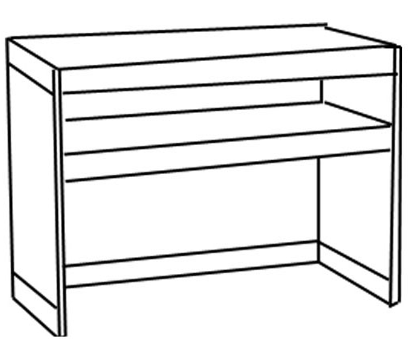 | Information Counter  100×50×80cm | 60.00 |  |  |  | OE01 | 问讯台100×50×80cm | 150.00
OE02  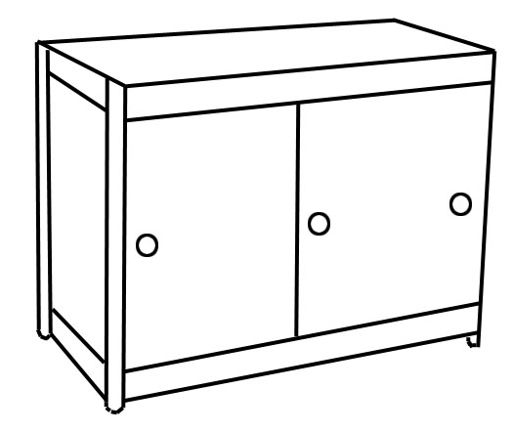 | Lockable Cupboard  100×5×80cm | 85.00 |  |  |  | OE02 | 锁 柜100×5×80cm | 240.00
OE03  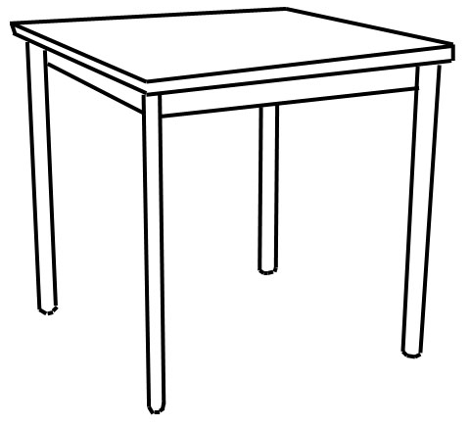 | Square Table  80×80×80cm | 60.00 |  |  |  | OE03 | 方台80×80×80cm | 160.00
OE04  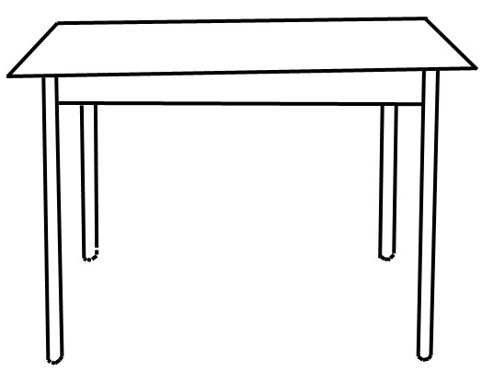 | Coffee Table  50×50×50cm | 25.00 |  |  |  | OE04 | 咖啡台50×50×50cm | 120.00
OE05  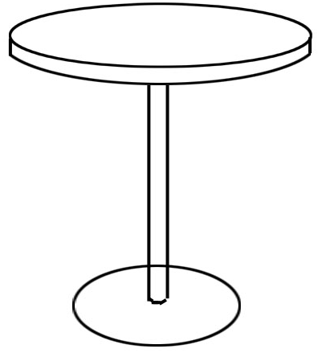 | Round Table  75×80cm | 60.00 |  |  |  | OE05 | 圆台  75×80cm | 120.00
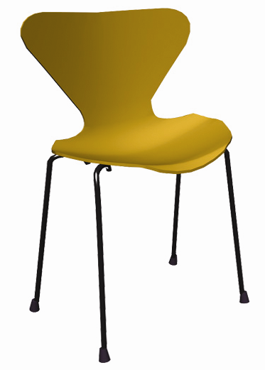  OE06 | Conference Chair | 20.00 |  |  |  | OE06 | 会议椅(蓝色) | 50.00
OE07  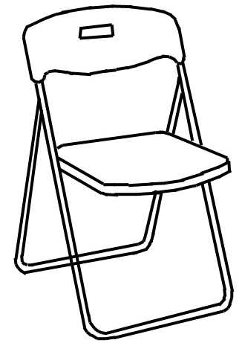 | Folding Chair  （white） | 20.00 |  |  |  | OE07 | 折椅（白色） | 50.00
OE08  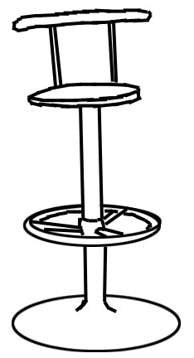 | Bar Stool | 45.00 |  |  |  | OE08 | 吧椅 | 150.00
OE09   | One Seat Sofa | 60.00 |  |  |  | OE09 | 单人沙发 | 200.00
OE10  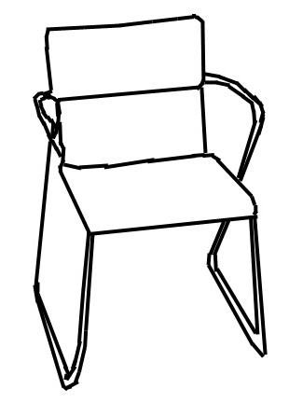 | Conference Chair  With Arms | 45.00 |  |  |  | OE10 | 黑色带扶手皮椅 | 150.00

展位号(Booth No.): | 公司名称(Name): |  | 表格  FORM | 5
联系人(Contact): | 电话(Tel): | 传真(Fax): | 表格  FORM | 5
截止日期/DEADLINE: 2013年4月29日/April 29, 2013

FURNITURES RENTAL (2) 家具订单（2）
Item | Specification | USD | Quantity | Total |  | 项目编号 | 描述 | 单价RMb | 数量 | 金额
OE11  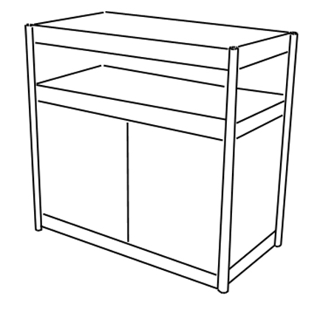 | Low Glass Showcase | 150.00 |  |  |  | OE11 | 低玻璃柜100×50×100cm | 350.00
OE12  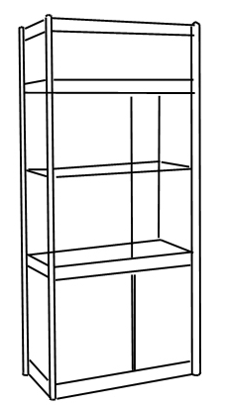 | Tall Glass Showcase | 350.00 |  |  |  | OE12 | 高玻璃柜100×50×200cm | 600.00
OE13   | Carpet/m2 | 10.00 |  |  |  | OE13 | 地毯\m2 | 30.00
OE14  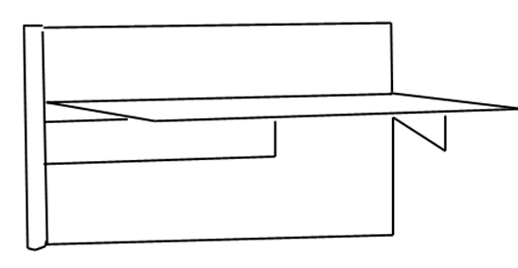 | Shelf | 40.00 |  |  |  | OE14 | 斜层板  100×30cm | 60.00
OE15  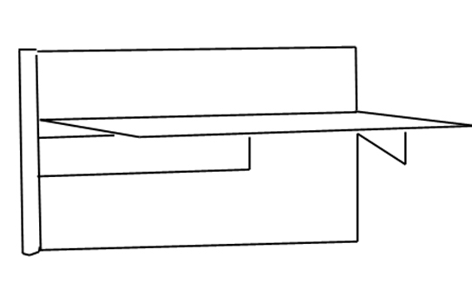 | Shelf | 20.00 |  |  |  | OE15 | 平层板  100×30cm | 60.00
OE16  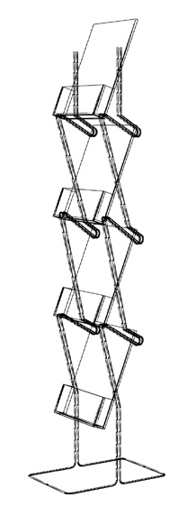 | Literature Rack | 35.00 |  |  |  | OE16 | 资料架 | 150.00
OE17  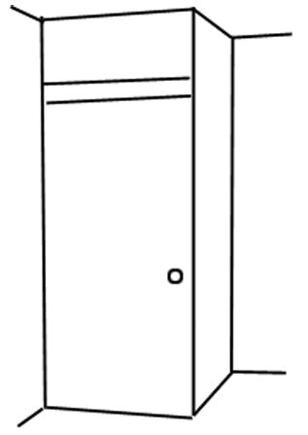 | Wooden Door  Wiith Cock | 100.00 |  |  |  | OE17 | 锁门（铁制） | 400.00
OE18  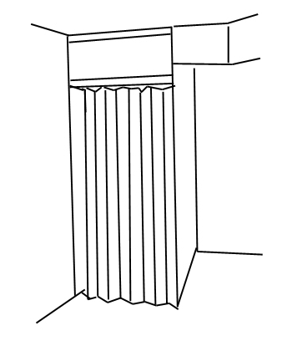 | Flolding Door | 80.00 |  |  |  | OE18 | 折门 | 200.00
OE19  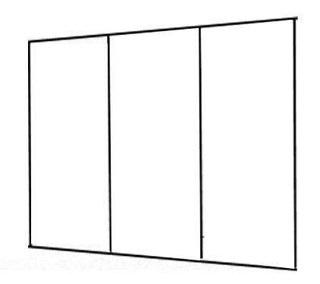 | Panel | 60.00 |  |  |  | OE19 | 墙  2400x980cm | 240.00
OE20   | Waste Basket | 10.00 |  |  |  | OE20 | 纸篓 | 25.00
OE21  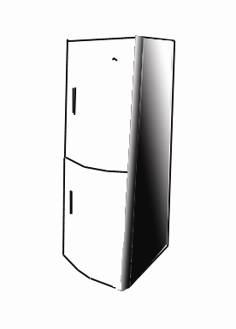 | Large Refrigerator | 150.00 |  |  |  | OE21 | 电冰箱 | 800.00
OE22   | Plant | 30.00 |  |  |  | OE22 | 植物 | 120.00
OE23  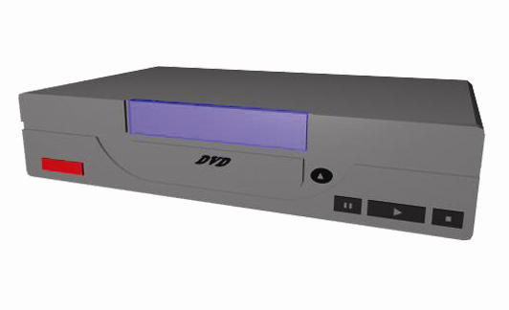   | Plasma TV | 400.00 |  |  |  | OE23 | 等离子电视  VCD/DVD | 2,000.00
OE24  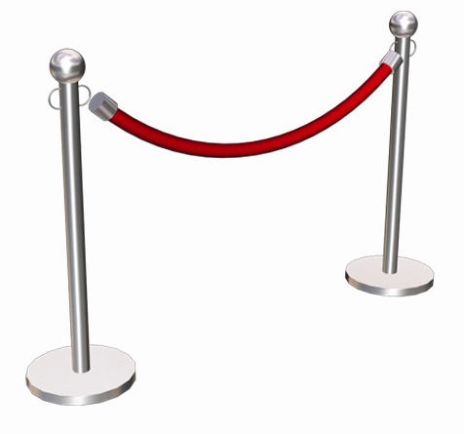 | Chain Post | 30.00 |  |  |  | OE24 | 链柱(米) | 150.00

Authorized Signature & Company Chop Name (Please Print) Signature Date & Place
负责人签字及公司盖章 负责人姓名(请用正体) 签字日期及地点

PLEASE RETURN THIS FORM TO / 此表请传真或邮寄到:
BEIJING PERFECT CREATIVE INTERNATIONAL BUILDERS RESOURCES CO.,LTD
ADD: No. 4 Building, Jing’an Xijie, Chaoyang District Beijing 100028, China
北京唯美创意国际展览服务有限公司 地 址：北京市朝阳区静安西街4号楼
CTC/联系人：Mr. Li Hui/李辉 先生 Ms. Li Shuang/李双 女士
Tel/电话：+86-10-84551155-812/838 13911283711, 15010081035 Fax/传真：+86-10-64625934
E-mail: lihuipbr@126.com, 15010081035@139.com

展位号(Booth No.): | 公司名称(Name): |  | 表格  FORM | 6
联系人(Contact): | 电话(Tel): | 传真(Fax): | 表格  FORM | 6
截止日期/DEADLINE: 2013年4月29日/April 29, 2013

FACILITIES Rental 租 用 设 备
Hire rate | USD | Quantity | total amount
10M | 9,450.00
20M | 14,360.00
256K | 1,300.00
512K | 1,650.00
1M | 2,500.00
2M | 4,000.00
2M＜rate＜＝10M | 15,000.00
※ INTERNET ※ 网线
租用速率 | 资费RMB | 数量 | 金额
10M | 45,000.00
20M | 67,500.00
256K | 6,200.00
512K | 8,400.00
1M | 12,200.00
2M | 21,800.00
2M＜速度＜＝10M | 68,200.00

Item | Deposit USD | Period USD | Quantity
IDD | 400.00 | 400.00
DDD | 200.00 | 260.00
Local Phone | 0.00 | 200.00
※TELEPHONE: ※ 电话设备:
项目编号 | 押金RMB | 单价RMB | 数量
国际电话 | 3,000.00 | 1,200.00
国内电话 | 500.00 | 1,000.00
本市电话 | 0.00 | 800.00

※POWER SUPPLY： ※ 用电:
Item | Specification | USA | Quantity | Total Amount |  | 项目编号 | 描述 | 单价RMB | 数量 | 金额
OE25 | Sun Lamp 150w | 200.00 |  |  |  | OE25 | 金卤灯300w | 260.00
OE26 | Short Spotlight 100w | 55.00 |  |  |  | OE26 | 短臂射灯100w | 110.00
OE27 | Long Spotlight 100w | 60.00 |  |  |  | OE27 | 长臂射灯100w | 120.00
OE28 | Fluorescent Tube | 50.00 |  |  |  | OE28 | 日光灯40w | 100.00
OE29 | Socket ≤1kw | 50.00 |  |  |  | OE29 | 插座≤1kw | 100.00

备注： 1.此租赁表格请于2013年4月29日之前传真至唯美展览公司。
2.迟于截止日期的订单将被加收30％的附加费，现场订单将被加收50％的附加费。

Authorized Signature & Company Chop Name (Please Print) Signature Date & Place
负责人签字及公司盖章 负责人姓名(请用正体) 签字日期及地点

主场承建商
北京唯美创意国际展览服务有限公司
公司地址：北京市朝阳区静安西街4号楼 邮政编码：100028
电话：+86-10-84551155 传真：+86-10-64625934/64661298
联系人：李辉 13911283711 网址：www.pbr.net.cn
● 水、电、压缩空气申请及报馆相关手续
联系人：李双 15010081035 电子邮箱：15010081035@139.com
电话：+86-10-84551155 ext.838 传真：+86-10-64625934/64661298ril 29, 2013
● 标准展位及家私租赁
联系人：李超 15210127035 电子邮箱：Lee-ch3116@sina.com
电话：+86-10-84551155 ext.836 传真：+86-10-64625934/64661298
账户信息：
公司名称：北京唯美创意国际展览服务有限公司
开户银行：北京银行北苑路支行
银行地址：北京市朝阳区北苑路172号欧陆经典B座首层
帐 号：01091081800120109040136
银行行号：1081

PLEASE RETURN THIS FORM TO / 此表请传真或邮寄到:
BEIJING PERFECT CREATIVE INTERNATIONAL BUILDERS RESOURCES CO.,LTD
ADD: No. 4 Building, Jing’an Xijie, Chaoyang District Beijing 100028, China
北京唯美创意国际展览服务有限公司 地 址：北京市朝阳区静安西街4号楼
CTC/联系人：Mr. Li Hui/李辉 先生 Ms. Li Shuang/李双 女士
Tel/电话：+86-10-84551155-812/838 13911283711, 15010081035 Fax/传真：+86-10-64625934
E-mail: lihuipbr@126.com, 15010081035@139.com
展位号(Booth No.): | 公司名称(Name): |  | 表格  FORM | 7
联系人(Contact): | 电话(Tel): | 传真(Fax): | 表格  FORM | 7
截止日期/DEADLINE: 2013年4月29日/Apr. 29, 2013

INVITAION LETTER FOR  VISA-APPLICATION  The exhibition organizer can issue the official invitation letter to the foreign exhibitors on their request for applying the visas to the  People Republic of China at the rate of USD38.00 / person..  After the receipt of this form and the confirmation of payment,  it will take about one week to get the approval from the Beijing Municipal Government.  ●WE NEED YOUR OFFICIAL INVITATION LETTERS:  For__________ persons applying for their visas to China, At USD in total: ____________________ | 邀 请 函  （申请签证）  展览主办单位可以向提出要求的参展商发出正式的邀请函，以便申请中华人民共和国入境签证。手续费为  ¥249.00元/人。  在收到本表及确认支付手续费后，展览主办单位约需一周时间办理有关手续，以获得北京市政府有关部门的批准。  ●我公司需要贵单位发出正式邀请函：  以申办我公司___位参展商之中国签证。  我公司需支付手续费共计人民币___元。

Company Name  公司名称 |  |  |  |  |  |  | Fax No.  传真号
Company Add.
公司地址
Business Scope
公司业务范围
Estimated Arriving Date in China  拟 抵 华 日 期 |  |  |  |  | Duration of Staying in China  拟 在 华 停 留 天 数
City of Your Entrance in China  入 境 地 点 |  |  |  |  | Visa Issued City in Your Country  签 证 地 点
No. 序号 | Full Name of Applicant申请人姓名 |  | Sex  性别 | Nationality  国籍 |  | Position  职务 |  |  | Passport Number  护照号码
01
02
03
04
05
06
07
08
09
●USE EXTRA PAPER IF NECESSARY ●如需要，可另附纸。

Authorized Signature & Company Chop Name (Please Print) Signature Date & Place
负责人签字及公司盖章 负责人姓名(请用正体) 签字日期及地点

PLEASE RETURN THIS FORM TO / 此表请传真或邮寄到:
Beijing World trade Centre ADD: 2nd Floor Jianbang Business Center, No.19 Nanlishilu, Xicheng District, Beijing 100045, China
北京世界贸易中心 地址：北京市西城区南礼士路19号建邦商务会馆2层
CTC/联系人： Ms. Liu Jie /刘洁 女士, Ms. Qi Wei/齐溦 女士, Tel/电话：+86-10- 68066685, 68066686
Fax/传真：+86-10- 68066969 E-mail: lj@wtcbj.com; qw@wtcbj.com

展位号(Booth No.): | 公司名称(Name): |  | 表格  FORM | 8
联系人(Contact): | 电话(Tel): | 传真(Fax): | 表格  FORM | 8
截止日期/DEADLINE: 2013年4月29日/Apr. 29, 2013

ACCOMMODATION /推荐酒店
序号  Choice  Code | 酒店名称  Hotel Name | 星 级  Hotel  Category | 展会特价  Special Room Rate | 距展场距离Distance to CIEC | 酒店地址  Hotel Address
No.1 | 渔阳饭店  Yu Yang Hotel | ★★★★★ | 人民币850元（含1人中西式早餐）  USD140 Standard with 1 person's Breakfast | 2.5公里  about 2.5 km | 朝阳区新源西里中街18号/ No. 18, Xinyuanxili Zhongjie, Chaoyang Dist., Beijing
No.2 | 实华饭店  Shihua Hotel | ★★★ | 人民币360元（含2人早餐）  USD58 Standard with 2 person's Breakfast | 1公里  about 1 km | 朝阳区西坝河东里14号/ No. 14  Xibahe Dongli, Chaoyang Dist., Beijing
No.3 | 国展宾馆  Guozhan Hotel | ★★ | 人民币280元（无早餐）  USD43 Not including Breakfast | 展场对面，0.2公里  about 0.2 km | 朝阳区静安西街10号/ No. 10 Jingan Xijie, Chaoyang Dist., Beijing
No.4 | 明宫宾馆 | ★★ | 人民币280元（含2人早餐）  USD43 including Breakfast | 1.2公里  about 1.2 km | 朝阳区西坝河西里 16 号 /NO.16 / Xibahei,Chaoyang  Dist.,Beijing
No.5 | 总装招待所  Zongzhuang Hotel |  | 人民币248元（含2人早餐）  USD40 Standard with 2 person's Breakfast | 2公里  about 2 km | 朝阳区左家庄12号/ No. 12 Zuojiazhuang, Chaoyang Dist., Beijing

展商酒店住宿预定表

- 展览会指定旅游代理商：
公司名称 | 中旅体育旅行社有限公司
通讯地址 | 北京市朝外大街19号华普国际大厦1507B室 |  |  | 邮政编码 | 100020
电 话 号 | 010-65802099
传 真 号 | 010-65802097 | 电子邮件 | robzhang6688@163.com
联 系 人 | 张桦 先生 13901104070 李瑞英 女士 15911076909
- 参展厂商信息：
公司名称
通讯地址 |  |  |  | 邮政编码
电 话 号
传 真 号 |  | 电子邮件
联 系 人 |  | 手 机 号

3-酒店预订住宿：
酒店名称 | 房间类型 | 客人姓名 | 性别 | 用房数 | 住店日期 | 离店日期
4- 酒店预订提示：
1、结算方式：房费直接付酒店。
2、因房间数量有限，请提前将贵公司用房数量传真至我处010-65802097。
3、预订将保留至当天晚上的18:00，任何晚到店或更改预订请提前通知我公司。
4、请持我公司酒店确认函，到酒店办理入住手续。

Authorized Signature & Company Chop Name (Please Print) Signature Date & Place
负责人签字及公司盖章 负责人姓名(请用正体) 签字日期及地点

PLEASE RETURN THIS FORM TO / 此表请传真或邮寄到:
CtS Sports travel Service Co., ltd.
ADD: Room 1507B, Huapu Plaza, No19,Chaowai Avenve, Chaoyang Dist,Beijing 100020.China
中旅体育旅行社有限公司 地 址：北京市朝阳区朝外大街19号华普国际大厦1507B室
CTC/联系人：Mr. Zhang Hua/张桦 先生, Ms. Li Ruiying/李瑞英 女士
Tel/电话：+86-10-65802099 Fax/传真：+86-10-65802097 E-mail: robzhang6688@163.com

展位号(Booth No.): | 公司名称(Name): |  | 表格  FORM | 9
联系人(Contact): | 电话(Tel): | 传真(Fax): | 表格  FORM | 9
截止日期/DEADLINE: 2013年4月30日/Apr. 30, 2013
《科博会企业项目数据调查表》填写说明
一、 调查目的：
为更加高效、务实地为科技企业提供贸易促进服务，更大范围地促进科技项目交流合作，增强科博会参会企业实效，科博会组委会办公室设立此项《调查表》，收集全国各省市科技企业（含科博会参展参会企业）项目信息和招商意向，作为科博会的主要会议资料进行重点推广。经确认审核符合要求的填报单位和项目信息，将被纳入科博会企业项目数据库，作为重点服务内容，组织专门的项目推介活动。
二、 填报主体：
各省市、自治区、计划单列市经正式注册的科技研发经济主体；中央在京科技类经济主体；科博会参展参会的经济主体。
三、 填报要求：
（一） 本表由中文和英文两套表格组成，请务必 准确、完整 填写表中所列全部项目，否则将被视为无效表格；
（二） 翻译由填报单位自行负责；
（三） 提交时须在中英文表格的右上角加盖填报单位公章；
（四） 提交形式：电子邮件；
（五） 提交截止日期：2013 年 4 月 30 日；
（六） 如提交信息发生变化，填报单位应及时通知我会更新。
四、 本次调查不收取任何费用。
五、 填报单位提交的信息将不会用于以营利为目的的商业用途。
六、 本表解释权归科博会组委会办公室所有。
七、 联系方式：苏东龙 先生，电话：010-88070356, 电邮：1195682410@qq.com
刘 燕 女士，电话：010-88070326, 电邮：vivianliu@ccpitbj.org
传真：010-68065905

单位中文名称 / Enterprise Chinese Name
单位英文名称 / Enterprise English Name
注册日期 / Registered Date
注册资金 / Registered Capital
就业人数 / Number of Employment
行业类别 / Industry Category
主要产品或服务 / Main Products or Services
联系人姓名 / Contact Name
联系人职务 / Title of Contact Person
联系电话 / Tel
联系传真 / Fax
联系手机 / Cell
电子邮件 / Email
单位网址 / Homepage
邮政地址 / Postal Address
单位简介（200 字左右） / Brief Introduction to your Enterprise（at most 200 words）
对接项目及意向简介（200 字左右） / Brief Introduction to the Business-matching Porjects and Intentions（at most 200 words）
本表请填报单位复印保留。如有信息变更，请及时与我会联系。
please keep the copy of this form for you to let us know the modification of the submitted information.

